CSC309 Phase 3

Scrap Funder

By: David Eysman, Daniel Tjandra, Eric Feng, Samson Chung

76.64.52.134
https://github.com/AASchool/csc309

Table of Contents:
Feature and Functionality Specification | 3-5
Project Plan | 6-7
Software Architecture and High Level Design | 8-9
Information Representation | 10-11
Testing Strategy and Testing Plan | 12

2.1 Feature and Functionality Specification

Here's some functional requirements in the form of user stories. We plan to implement the most important functionalities and if we have extra time we will implement more functionalities but for now we are sticking with the following:
User Stories
- As an initiator, I would like to post project ideas so that funders may be appealed to support my project.
- As a user, I would like to see the current funding progress of the project so that I can see interests of the community on my project.
- As a user, I would like to have a profile to keep track of my own projects and projects I have funded to keep things organized.
- As a user, I would like to be able to modify my own profile so that the information is always accurate.
- As a user, I would like to see the projects that’s in my local area because some projects may be limited to certain areas.
- As a user, I would like to interact with the people in the projects that I am currently participating because project qualities and execution may improve by the feedbacks I get.
- As a user, I would like a rating system to give me the reputation of the people that i am interacting with so I can see if someone is known for being reliable or disturbing other people.
- As a funder, I would like to browse projects within a certain category so that I may rule out subjects that I am not interested it.
- As an initiator, I would like to be able to modify my project so that I can make changes according to the community
- As an admin, I would like a view of the system information to keep track of analytics of the website so that I can improve the website knowing some statistics of the system.
- As a user, I would like to be able to search for projects I am interested in

Here’s some possible user interactions with the system:
Every webpage of our system comes with a header and a footer (the footer is not shown here) to make navigation simple like many other websites out there.

Landing page [p1]:
There are several things that the users would do starting at the landing page. A familiar user is most likely to start by logging into her account to see the progress of her own project or the ones that she’s funding. Which takes us to the user dashboard page [p2]. On the other hand, new users and for those that are just browsing to see what’s interesting would either choose to sign up or start browsing the projects available. Users can click on the “more" or "explore" buttons to get to the project exploration page [p4]. We plan to put some “featured” projects on the landing page helping some projects to get recognition.

User dashboard page [p2]:
At the dashboard, users can easily navigate the projects that they are currently participating in.

Sign up/login page [p3]:
The signup and login page would most likely be very similar with simple text fields for user inputs.

Project Exploration Page [p4]:
At the Project Exploration Page, users can easily navigate through all the projects that are currently up and running and get more information about the projects. Users can click on any project and see more detailed information about the project at the Project Detail Page [p5]. We also plan to incorporate search, using SQL queries of tags, to find relevant projects in the next phase.

Project Detail Page [p5]:
In this page, users can watch a short clip about the project as well as reading some details and the progress about the project. Below the project title, we can see the project initiator along with his reputation rating in past projects that he has participated in. There will be a discussion board for users to interact and give feedbacks or comments about the project. You may also see updates of the project from time to time or follow ups from the initiator.

User profile page [p6]:
This page provides some information about the user as well as some options to update his or her password and perhaps some other information.
[p1]
[p2]
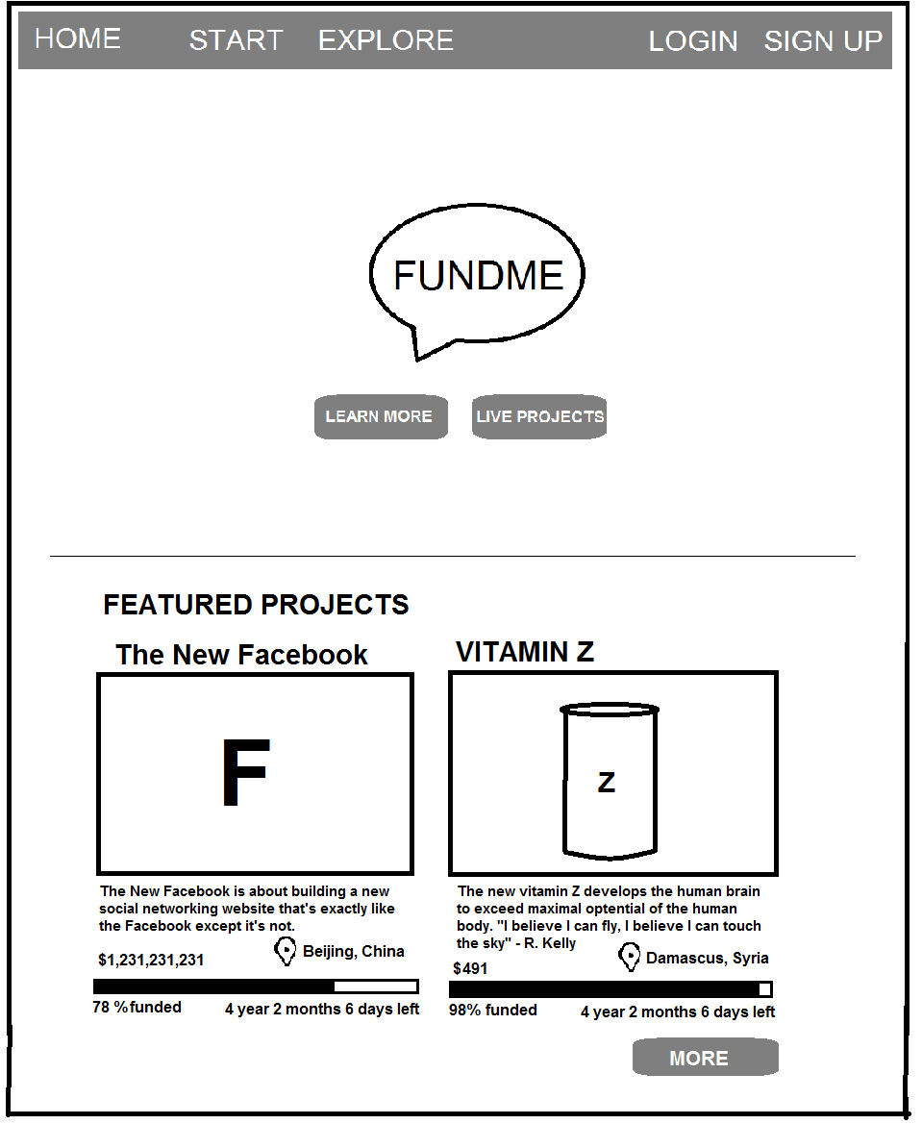
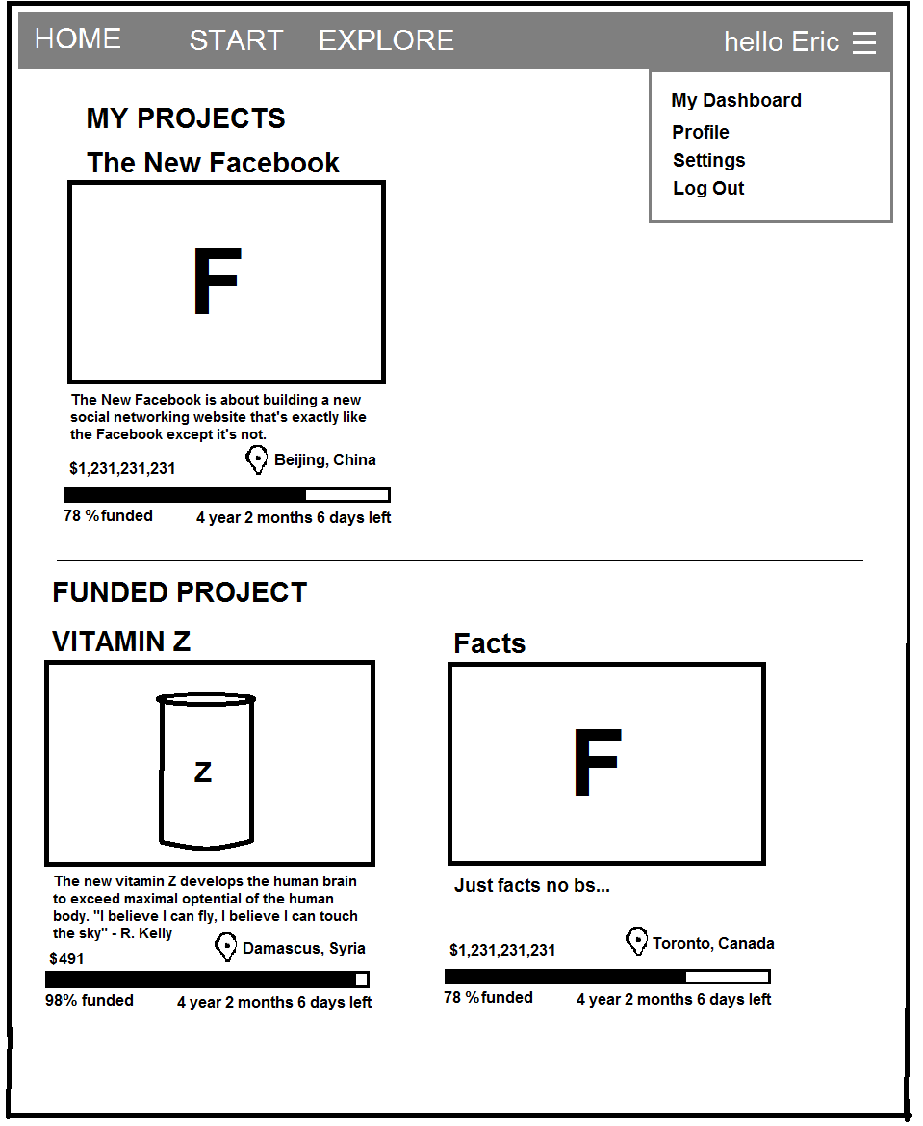

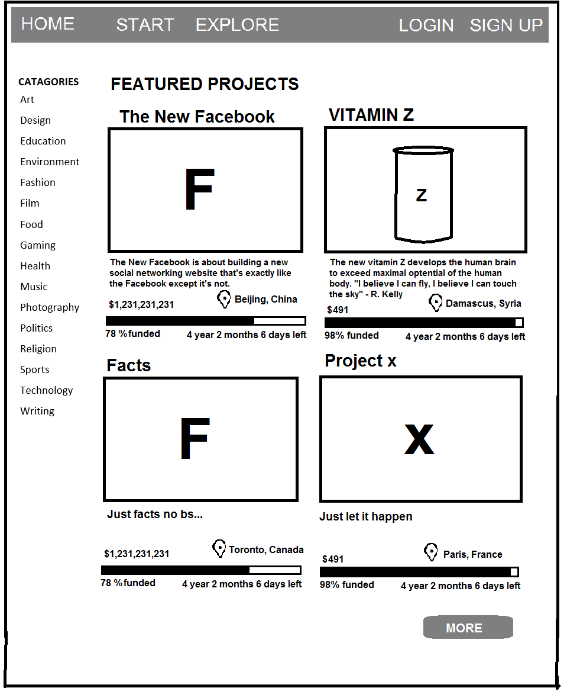
[p4]
[p5]
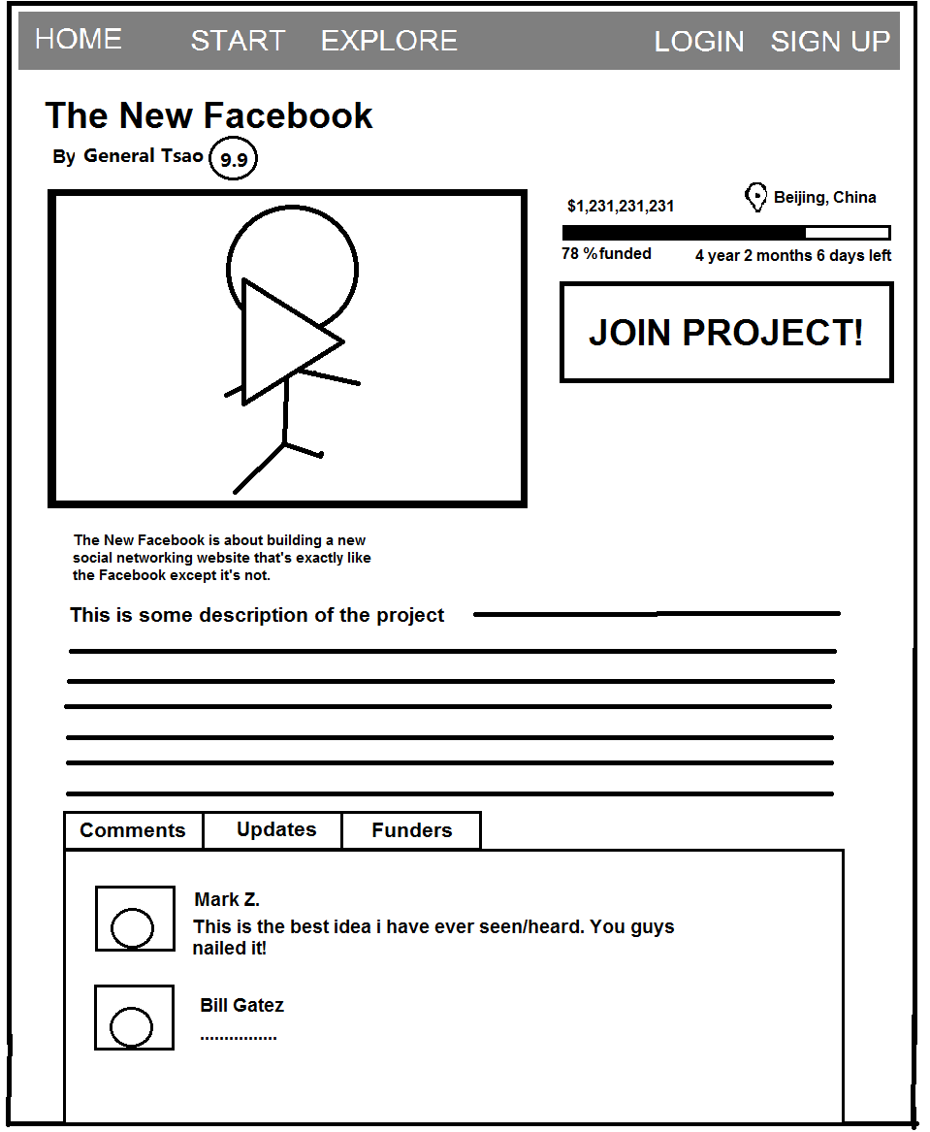

[p6]
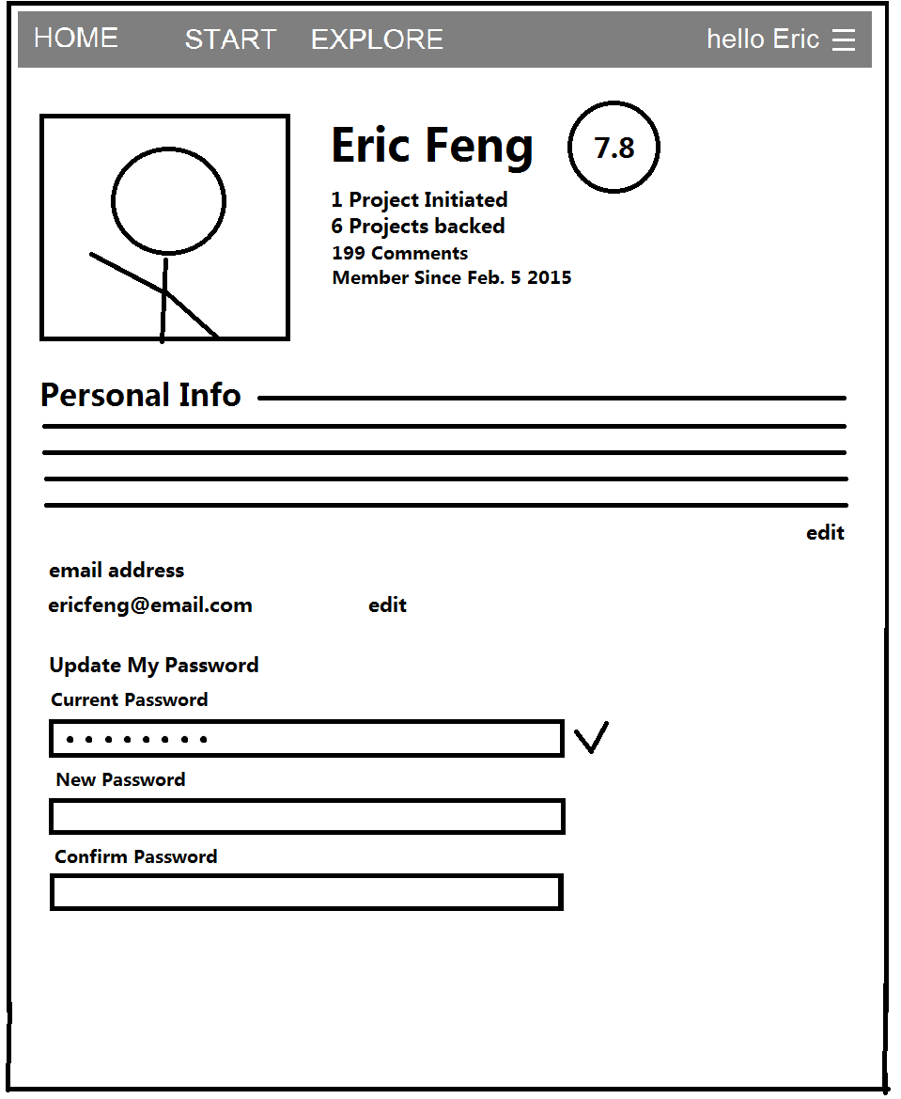

2.2 Project Plan
Personnel Roles:
- Daniel Tjandra - Back end, server setup, architecture design
- Samson Chung - Back end, database design and implementation, architecture design
- Eric Feng - Front end, website design/aesthetics, front end implementation
- David Eysman - Front end, implementation, data retrieval from back to front end

The team will use Google chat for communicating and Google docs for sharing progress on initial design of the website. Once development has started we will move on to using GitHub as a repository for code as well as using GitHub’s issue system to report and resolve problems. The team will hold a weekly meeting on Wednesdays to discuss and coordinate anything that cannot be done over Google chat. Major decisions about the direction the project will head in are to be discussed and made at these meetings. We have a Kanban board on trello.com to keep track of tasks as they transition between to-do, in progress, testing, and shipping.

Project Milestones:
Initial Design
Site map and databases initial designs
Component implementation
Database, web server and basic front end implemented. Core PHP, HTML and CSS in place. All buttons and visual design finalized
Website Alpha
Phase 1: User interface implemented but not fully functioning, may be some dead buttons. Login, user profile, project pages with comments, basic project search by name
Phase 2: Donate, review system, and admin system in place.
Both phases depend on database being operational.
Website Beta:
Fully functioning UI and search
Rigorous testing of client side

Timeline for Phase 4:

March 15-21:

- Allow users to add their own interests that are not pre-ade
- Allow users to be able to remove interests
- Add user experiences

March 22-28

- Incorporate search functionality
- Add friend list to user profile

March 29 – April 4

- Incorporate more administrative powers
  - Remove projects
  - Ban users
- Add images to projects
- Add images to users

2.3 Architecture and Design

Overview

The server is being hosted on one of the team member’s spare computers right now. It was the easiest way to host the server and allowed us easy access to it.

The information will all be stored in a postgres SQL server. We are choosing postgres because everyone is familiar with it from csc343 including some basic setup and administration. An SQL database also means we don't have to worry about the actual implementation of storing, sorting, indexing or optimizing our information. Using SQL queries makes our data easy to access.

We will be using PHP for our server side scripting. It seems to have a good online community as well as many extra modules to provide extra features we may need. It is fairly straight-forward to use, especially when imbedded inside html.

To host the website we will be using the apache http server since it is freely available and dependable.

To produce the actual front end we will be using twitter bootstrap. Because it is a complete front end framework, this will make it much easier to manage as opposed to using many different libraries. Twitter bootstrap is also growing in popularity so it will also be useful for future use. Twitter bootstrap also built in compatibilities for all the major browsers as well as being able to redraw the contents for smaller smart phone screens. Bootstrap provides visually appeasing web pages through their CSS files so we do not have to create style sheets from scratch.

Lastly, we will be sending all the information to the client by an https connection to ensure security and prevent unwanted eavesdropping. We will be using a self signed certificate for the process which is fine for our small project since we all trust each other.

Front end
Twitter bootstrap | Javascript
Https secure connection

Backend
Postgres SQL server | Php server side rendering
Apache http server | Self signed certificate

We have no middle-end currently planned because the business logic is fairly simple, thus the processes are directly from front-end to back-end It only consists of summing donations to their respective projects and updating the project statistics as needed. This can be done by php upon receiving a donation. Also, information coming from the database does not need much processing to be displayed on the website. Therefore, php can also do these simple calculations and then send it to the browser.

2.4 Information Representation
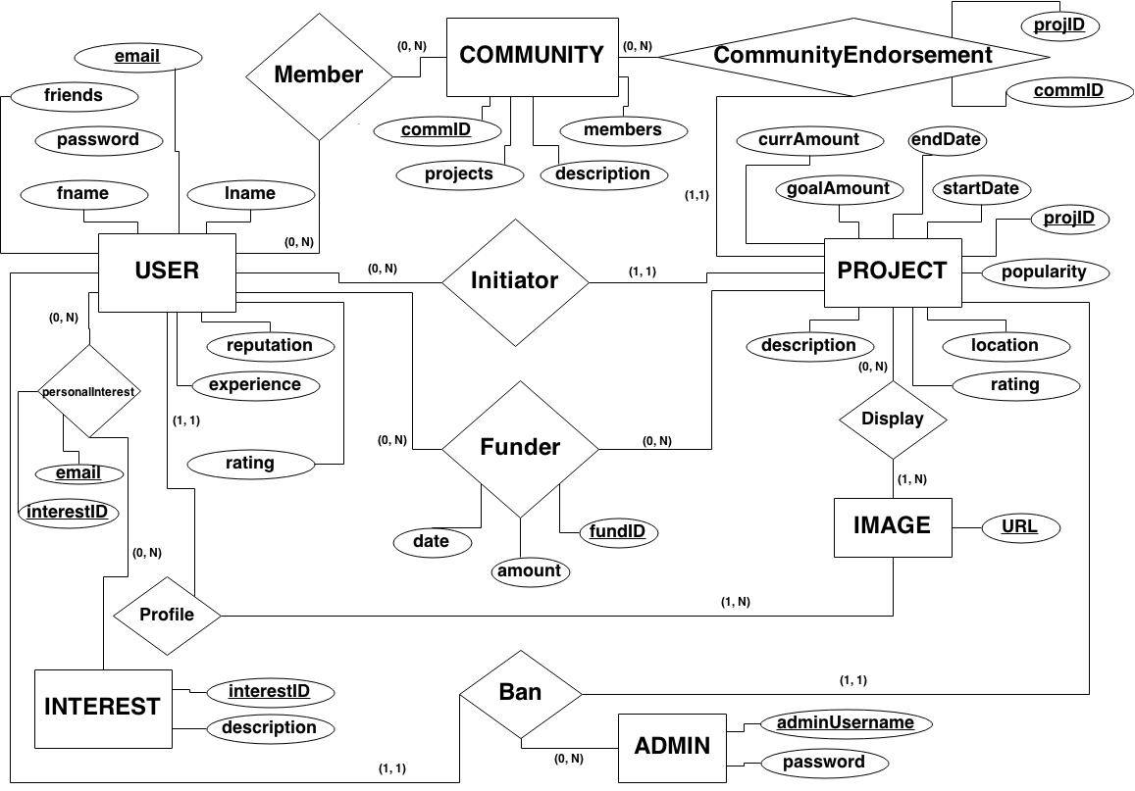

PersonalInterests
- email
- interestID
Project
- projID
- goalAmount
- currAmount
- startDate
- endDate
- description
- location
- popularity
- rating
Community
- commID
- members
- description
CommunityEndorsement
- commID
- projectID
Image
- URL
Initiator
- email
- projID
Funder
- fundID
- date
- amount
User
- email
- fname
- lname
- friends
- password
- reputation
- experiences

2.5 Test Strategy and Test Plan

For individual components of the system the team members who developed said components will be primarily responsible for testing. A Kanban board is being used so anyone with nothing to work on at the time can pick up the testing of an aspect of the project that they see in that section of the board. Any bugs that are found during testing will be submitted to GitHub using the issue system to keep track of code that is broken and what has been fixed.

Test Steps:

Team members will write unit tests during development of individual components of the website as part of the testing process. When unit tests are passed and the component is integrated into the system a variety of tests will be performed. Once the website is operational, part of testing will be to attempt to use all features through the UI including edge cases wherever text may be entered. This will be done across multiple browsers on different devices such as tablets so ensure the website is functioning for all users.

To test the overall functionality of the website, we will test scenarios to see if the website features are functional.

Scenarios:

- A user initiates a project with a negative goal amount
  - Make sure the website prevents this
- A user tries to give a negative donation
  - Make sure the website prevents this
- A user tries to create a fake/malicious project
  - Test if admin can remove this project and user
- A user accidentally double-donates
  - Confirm if users are donating multiple times
- A user wants to delete his project
  - Make sure it is removed properly
- A user tries to check his project history
  - Check if the history is correct by adding/removing projects

http://www.brokenlinkcheck.com/
Validates URLs by searching for dead links

Netsparker
Web Security Test tool: Checks for possible SQL injection and cross site scripting vulnerabilities.
Karma
JavaScript test running software for unit tests
PHPUnit
Unit testing framework for PHP

